Summary Pages and Views
Example:
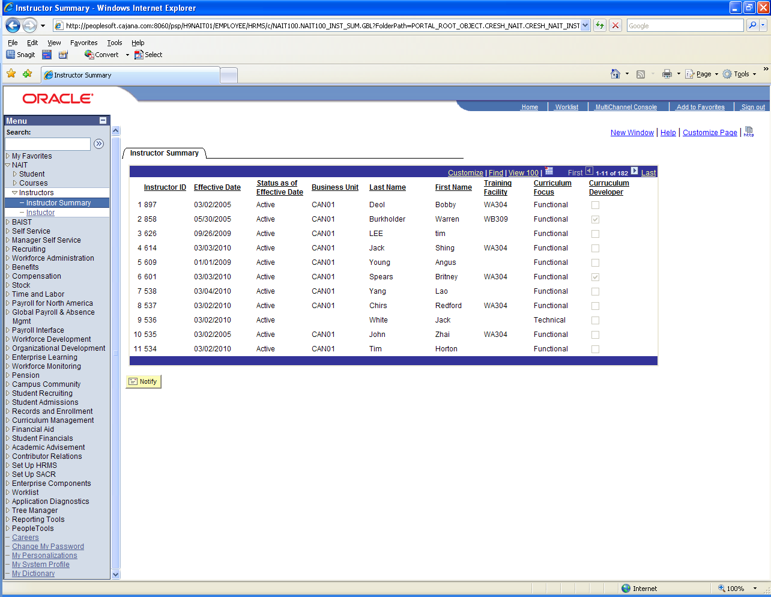
Project name: NAIT###_INS_SUM

Create View NAIT100_INST_VW:
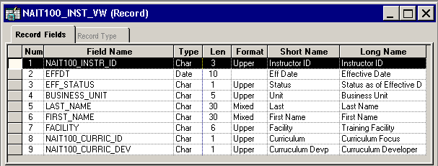
SELECT A.NAIT100_INSTR_ID, (CONVERT(CHAR(10),A.EFFDT,121)), A.EFF_STATUS, A.BUSINESS_UNIT, A.LAST_NAME, A.FIRST_NAME, A.FACILITY, A.NAIT100_CURRIC_ID, A.NAIT100_CURRIC_DEV
FROM PS_NAIT100_INSTR A
WHERE A.EFFDT =
(SELECT MAX(A_ED.EFFDT) FROM PS_NAIT100_INSTR A_ED
WHERE A.NAIT100_INSTR_ID = A_ED.NAIT100_INSTR_ID
AND A_ED.EFFDT <= SUBSTRING(CONVERT(CHAR,GETDATE(),121), 1, 10))

Create page NAIT###_INST_SUM:
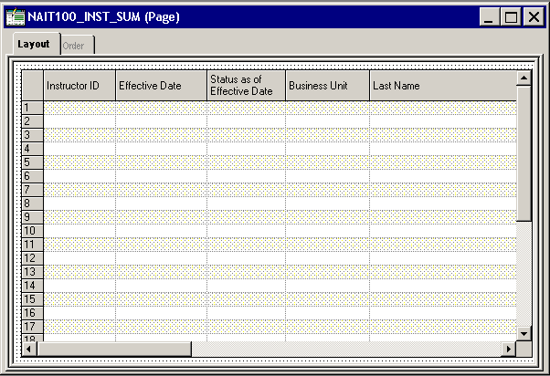

Page Grid Properties:
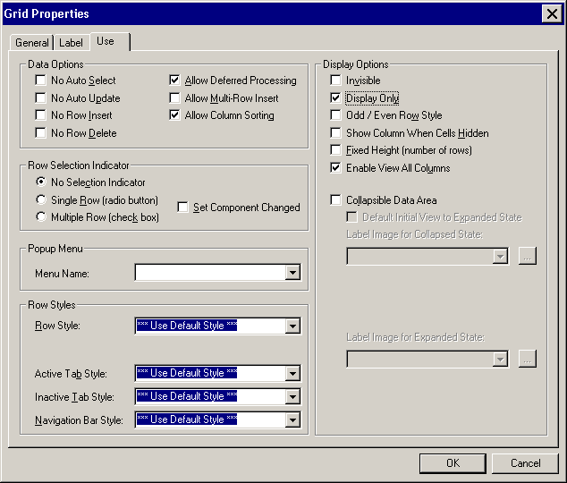

Create Component:
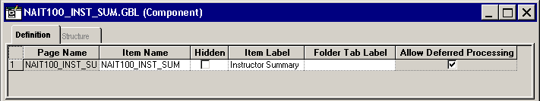
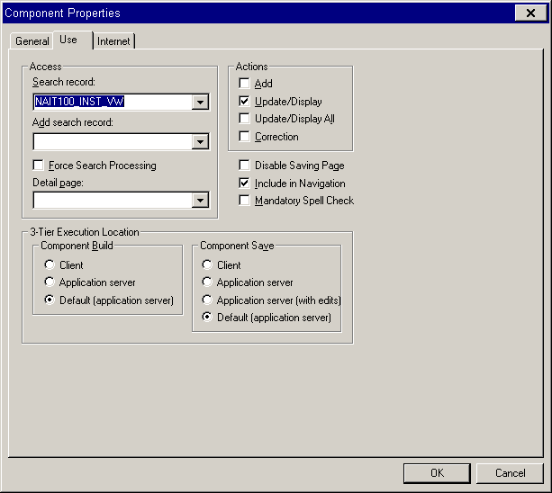
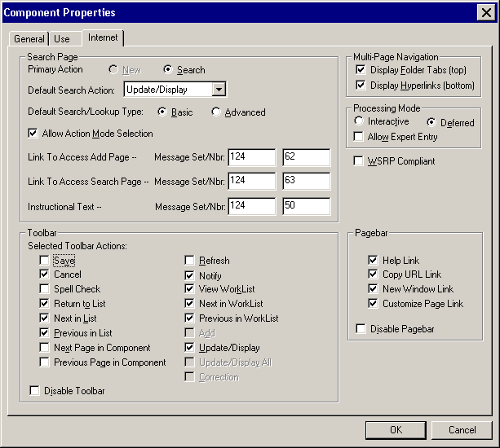

Register the Component

Test

